Table(s):

**Datapoint** ( datapoint_id, latitude, longitude, level_of_litter, num_litter_pieces, date_taken )

**ERD**

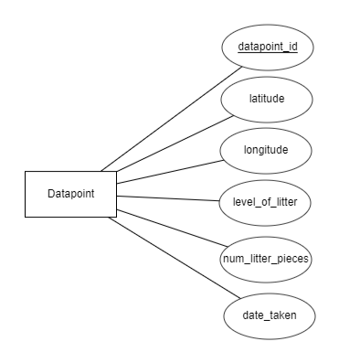

CREATE TABLE Datapoint (

datapoint_id INT AUTO_INCREMENT,

latitude FLOAT,

longitude FLOAT,

level_of_litter INT,

num_litter_pieces INT,

date_taken DATE

);